**Machine Learning – Lecture Notes – Part I**

**Week 1**

**Introduction**

Welcome

* Machine learning is all about building intelligent machines.
  + Grew out of the realm of AI
  + Gives new capabilities for computers
* Here are some examples of uses of machine learning:
  + Database mining
    - Large datasets from growth of automation/web
    - E.g. web click data (click-stream data), medical records, biology, engineering
  + Applications that can’t be programmed by hand
    - E.g. autonomous helicopter, handwriting recognition, most of Natural Language Processing (NLP), Computer Vision
  + Self-customizing programs
    - Amazon, Netflix product recommendations
  + Understanding human learning (brain, real AI)

What is Machine Learning?

* Machine Learning definitions:
  + Arthur Samuel (1959). Machine Learning: Field of study that gives computers the ability to learn without being explicitly programmed.
  + Tom Mitchell (1998). Well-posed Learning Problem: A computer program is said to *learn* from experience E with respect to some task T and some performance measure P, if its performance on T, as measured by P, improves with E.
* Machine learning algorithms generally fall under two categories.
  + Supervised learning
  + Unsupervised learning
* Other algorithms include: reinforcement learning, recommender systems.

Supervised Learning

* Let’s start with an example. Let’s say you want to model housing prices in a city. You collect a dataset as shown below.

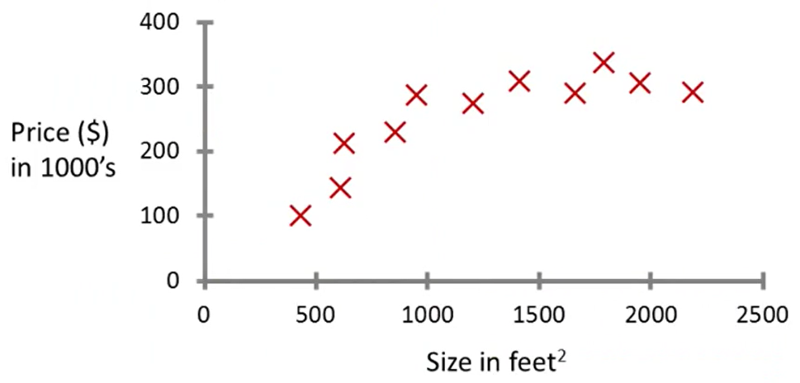

* A simple algorithm might just put a line of best fit through the data set. A better algorithm might use a quadratic to model the data.
* But this is an example of a supervised learning algorithm.
  + “Right answers” are given
* This is also called a **regression** problem. Regression is used to predict a **continuous** valued output (price).
* Another example is finding weather a breast tumour is malignant or benign, based on size. Let’s say we get the graph below.

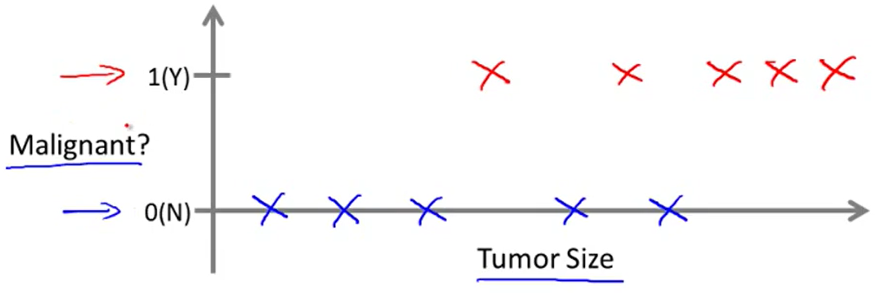

* Let’s say a friend has tumour of a certain size. Is it possible to find the probability that the person has a malignant tumour?
* This is known as a **classification** problem. Classification is used to predict a **discrete** valued output (0 or 1).
* In classification problems, there is also a slightly different way to plot this data. This data is all plotted on a 1-dimensional scale.

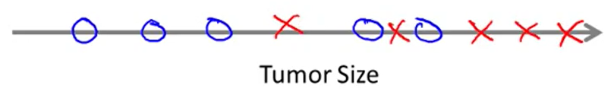

* This is important because when you have multiple attributes, you get higher dimensional data, which is harder to plot.
* Let’s say we know each patient’s age and tumour size (and whether it was malignant/benign). The graph may look like the following.

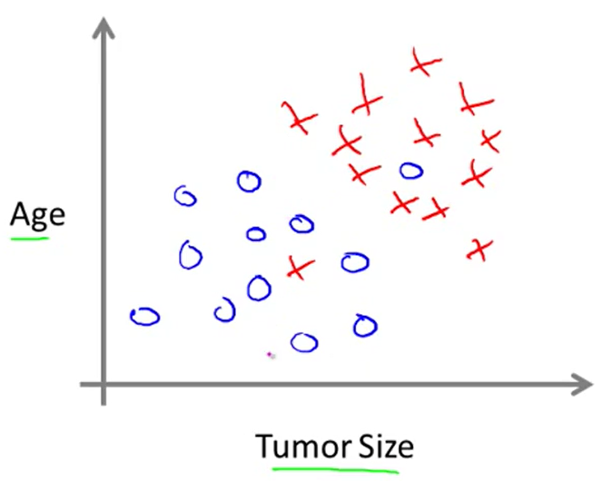

* Again, if you have a friend has a tumour, you could use a model to find the probability that she has a malignant tumour.
* You could fit a straight line through the data, for instance.

Unsupervised Learning

* In an unsupervised learning algorithm, a computer is given a data set, but it is not told what data points are correct and what data points are incorrect. Instead, all the data points seem uniform.
* A computer might be given the data set below.

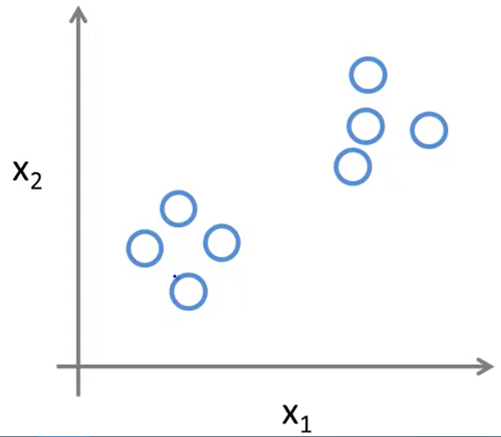

* The algorithm analyzing this data could decide that it lives in two clusters.

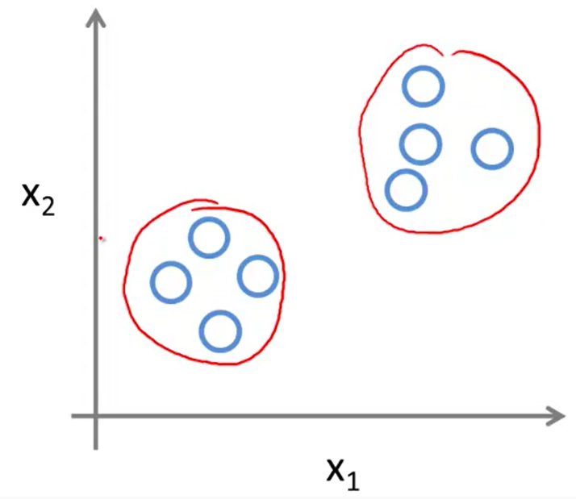

* This is called a **clustering algorithm**. This algorithm is used by Google News. When you look at an article on Google News, it suggests links that are related to that story.
* Clustering algorithms are also used in understanding genomics. For example, take a collection of 1,000,000 genes, and find a way to automatically group these genes into groups that are somehow similar or related by different variables, such as lifespan, location, roles, and so on.
* It is also used in organizing computer clusters, analyzing social networks, market segmentation, and astronomical data analysis.
* Non-clustering algorithms are used to find structure in a chaotic environment (e.g. identifying individual sound tracks or voices from a mesh of sounds at a cocktail party).

**Model and Cost Function**

Model Representation

* Let’s refer to the last example of selling houses in Portland, OR. The data that you feed into the algorithm is called the **data set** or **training set**.
* Notation of the training sets will be used as follows.
  + **m** = number of training examples
  + **x**’s = “input” variables / features
  + **y**’s = “output” variables / “target” features
  + **(x, y)** = one training example
  + **(x(i), y(i))** = the ith training example
  + **X** = the space of input values **x**
  + **Y** = the space of output values **y**
* To describe the supervised learning problem more formally, our goal is, given a training set, to learn a function $h:X→Y$ so that $h\left(x\right)$ is a “good” predictor for the corresponding value of *y*.
* The way this training set is used is that the set is fed into the learning algorithm, which improves the hypothesis function *h*. The function *h* maps some set of *x*’s to some set of *y*’s.

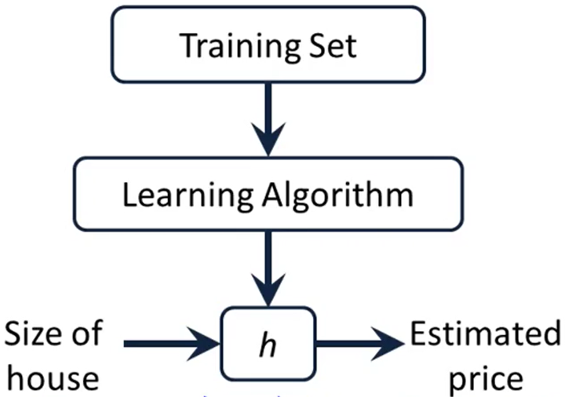

* In this case the *x* is the size of house (ft2) and the *y* is the estimated price ($).
* The next critical question is, how to we pick a hypothesis *h*? For now, we will say that our $h_{θ}\left(x\right)$ is a linear function.
$$h_{θ}\left(x\right)=θ_{0}+θ_{1}x$$

* This model is called linear regression with one variable or **univariate linear regression**.

Cost Function

* In a linear regression, we have both a training set and a hypothesis function.
  + Hypothesis: $h_{θ}\left(x\right)=θ_{0}+θ_{1}x$
  + $θ_{i^{'}s}$: Parameters
* In this video, we learn how to choose the parameters $θ_{0}$ and $θ_{1}$.
* **Idea:** Choose $θ_{0}$ and $θ_{1}$ so that $h_{θ}\left(x\right)$ is close to $y$ for our training examples $\left(x,y\right)$.
* We can do this by minimizing over $θ_{0}$ and $θ_{1}$. Thus, we must minimize the function below, which is the sum of squares of differences between the predicted and actual values in a training set.

$$J\left(θ_{0},θ_{1}\right)=\frac{1}{2m}\sum_{i=1}^{m}{{\left(h_{θ}\left(x^{\left(i\right)}\right)-y^{\left(i\right)}\right)}^{2}}$$

* This is also known as the squared error function. The mean is halved $\left(\frac{1}{2}\right)$ as a convenience for computing the gradient descent, as the derivative term of the function will cancel the $\frac{1}{2}$.

Cost Function – Intuition I

* To better visualize the function $J\left(θ_{0},θ_{1}\right)$, we will use a simplified cost function $J\left(θ_{1}\right)$. The function $h_{θ}\left(x\right)=θ_{1}x$. Then we get the cost function below.
$$J\left(θ_{1}\right)=\frac{1}{2m}\sum_{i=1}^{m}{{\left(h_{θ}\left(x^{\left(i\right)}\right)-y^{\left(i\right)}\right)}^{2}}$$

$$J\left(θ_{1}\right)=\frac{1}{2m}\sum_{i=1}^{m}{{\left(θ_{1}x^{\left(i\right)}-y^{\left(i\right)}\right)}^{2}}$$

* Now the goal is to minimize $J\left(θ_{1}\right)$ over $θ_{1}$.
* Let’s better understand both functions.
  + $h_{θ}\left(x\right)→$ for a fixed $θ_{1}$, this is a function of $x$
  + $J\left(θ_{1}\right)→$ function of a parameter $θ_{1}$
* To minimize this function, you can pick different values of $θ_{1}$ and see what values are returned from $J\left(θ_{1}\right)$. Then, you get a cost function. You pick the minimum value of $θ_{1}$ to get the best linear model for the data.

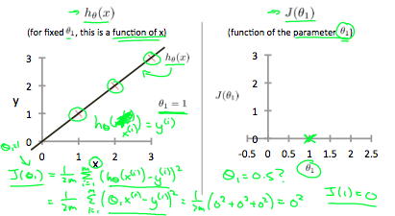

* This is one example where the training set consists of the points $\left(x,y\right):\left\{\left(1,1\right), \left(2,2\right),\left(3,3\right)\right\}$. If we use a $θ_{1}=1$, we get a line that passes through all points and $J\left(θ_{1}\right)=0$.

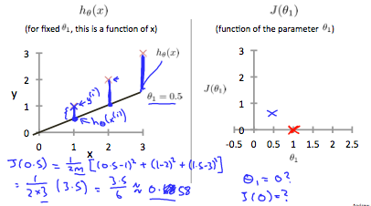

* If we use a $θ_{1}=0.5$, then $J\left(θ_{1}\right)≈0.58$, which is a worse model than the previous one. Eventually, we get the following graph.

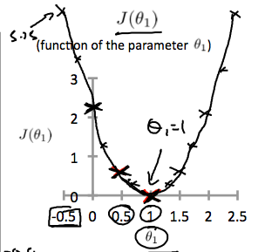

* This shows that the global minimum occurs at $θ_{1}=1$, which is the optimal value of the hypothesis function $h_{θ}\left(x\right)$.

Cost Function – Intuition II

* Now we will look at the entire cost function, including both parameters $θ_{0}$ and $θ_{1}$.

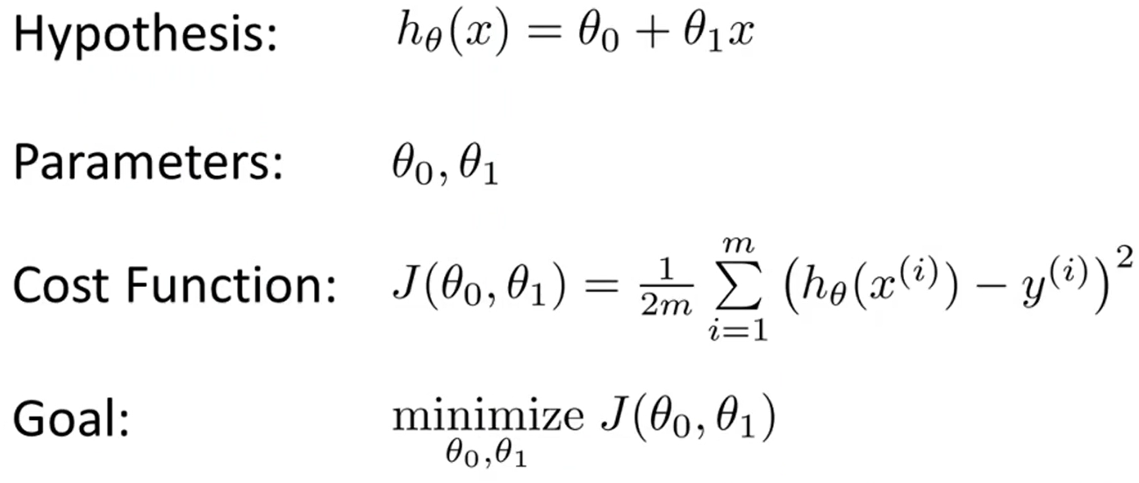

* A contour plot is a graph that contains many contour lines. A contour line of a two variable function has constant value for all points on an individual line.
* When we plot $J(θ_{0}, θ_{1})$, we get a contour plot on a 2D graph since we cannot plot all 3 dimensions. The function looks like below for a specific example.

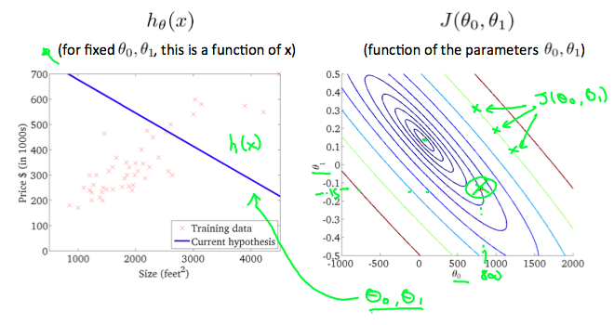

* This graph is quite far from the center of the ellipses in the contour graph. Thus, it means that the value of $J(θ_{0}, θ_{1})$ is quite high.

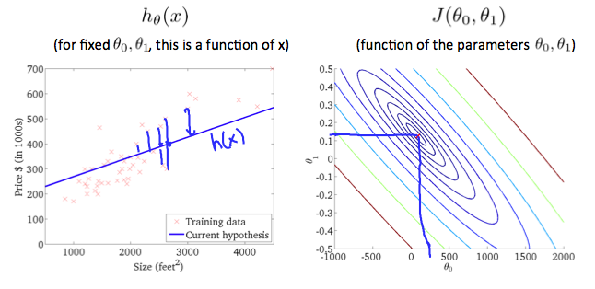

* When a new line of best fit is taken, it shows that the value of $J(θ_{0}, θ_{1})$ is very low because it lies near the center of the smallest circle on the contour graph. Thus, it is the line of best fit for the data.

**Parameter Learning**

Gradient Descent

* Here is the outline of the problem we hope to solve with a method called **gradient descent**.

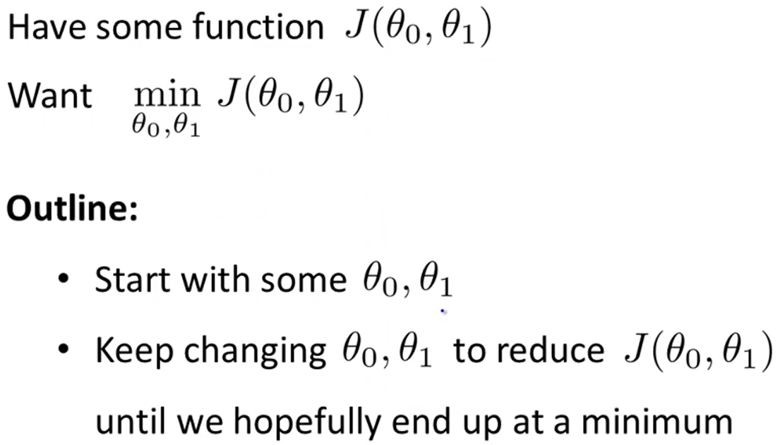

* Commonly, we initialize the variables to $θ_{0}=0,θ_{1}=0$.
* The intuition behind the gradient descent algorithm is as follows. Let’s say you’re standing on a hilly terrain as shown in the graph below.

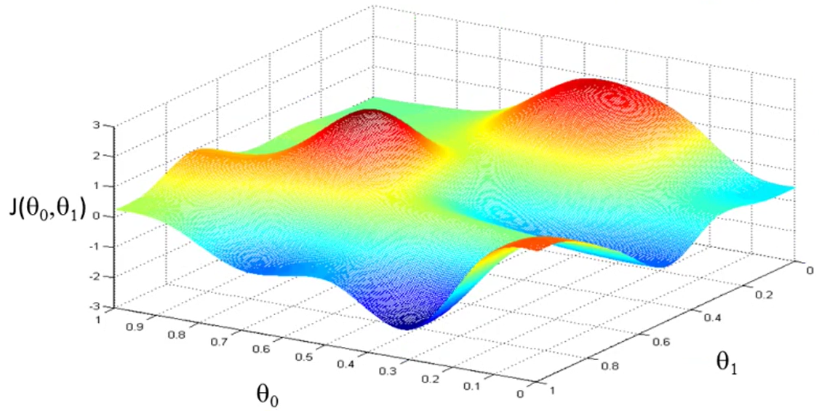

* The gradient descent algorithm will start a specific point. It will then look 360° and find the direction that will take it downhill most quickly. It might form a path like the one below.

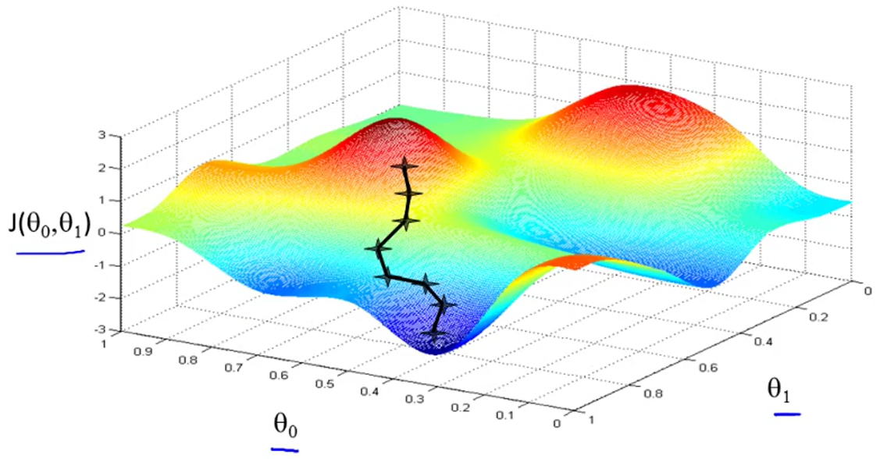

* However, this algorithm doesn’t always find the **global minimum** – it finds the **local minimum** that is easiest to reach.
* Now we’ll look at the gradient descent algorithm.
$$repeat until convergence \{ \\ θ_{j}≔θ_{j}-α\frac{∂}{∂θ_{j}}J\left(θ_{0},θ_{1}\right) for (j=0, 1) \\ \}$$

* The $≔$ symbol is the assignment operator. It means override the value of the left side with the value of the right side (in computer science).
* The $α$ represents the magnitude of the step that the algorithm takes in any direction. It is also called the **learning rate**.
* The last term $\frac{∂}{∂θ_{j}}J\left(θ_{0},θ_{1}\right)$ is the partial derivative of the cost function $J\left(θ_{0},θ_{1}\right)$ with respect to $θ_{j}$.
* We can do this simultaneously updating both variables using the following method.

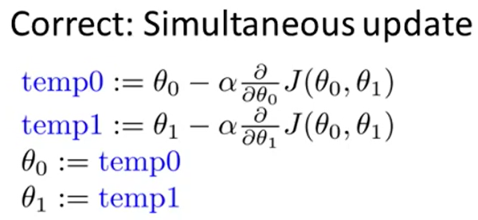

Gradient Descent – Intuition

* We saw the method of gradient descent last video. Here, we will show what the learning rate ($α$) and derivative term ($\frac{∂}{∂θ_{j}}J\left(θ_{0},θ_{1}\right)$) mean.
* We will consider problems of the form $\min_{θ_{1}}{J\left(θ_{1}\right)}$, where $θ_{1}∈R$.
* Then let’s see a function $J\left(θ_{1}\right)$ that needs to be minimized. The following shows such a graph. As shown, if $θ_{1}>θ_{min}$, then the $θ$ is updated to the left, and vice versa on the other side of the graph.

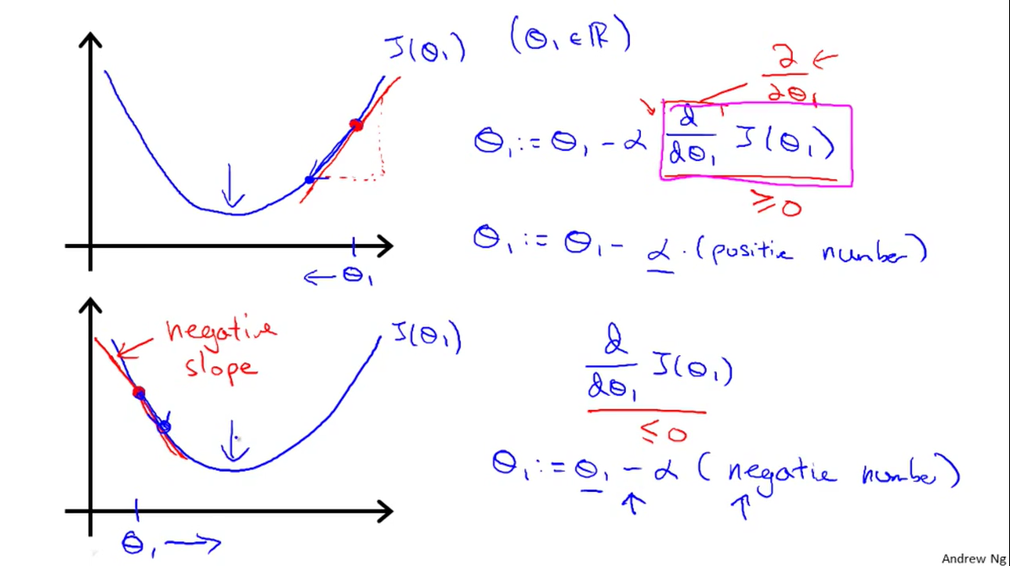

* If $α$ is too small, the gradient descent algorithm might work very slowly.
* If $α$ is too large, the gradient descent algorithm can overshoot the minimum. It may fail to converge and thus diverge – yielding no solution.
* If the gradient descent algorithm finds a local minimum, then it updates as follows.
$$θ_{1}≔θ_{1}-α\frac{d}{dθ_{1}}J\left(θ_{1}\right)$$

$$\frac{d}{dθ_{1}}J\left(θ_{1}\right)=0 (since it is a local minimum)$$

$$θ_{1}≔θ_{1}-α∙0$$

$$θ_{1}≔θ_{1}$$

* Gradient descent can converge to a local minimum, even with a fixed learning rate $α$.
* As the algorithm approaches the minimum, gradient descent will automatically take smaller steps. Thus, no need to decrease $α$ over time.

Gradient Descent for Linear Regression

* To find out how to apply this gradient descent method to linear regression, the key term to calculate is $\frac{∂}{∂θ_{j}}J\left(θ_{0},θ_{1}\right)$.
* Let’s find the partial derivative of the cost function with respect to each of the variables $θ_{0}$ and $θ_{1}$.
$$\frac{∂}{∂θ_{j}}J\left(θ_{0},θ_{1}\right)=\frac{∂}{∂θ_{j}}\left(\frac{1}{2m}\sum_{i=1}^{m}{{\left(h_{θ}\left(x^{\left(i\right)}\right)-y^{\left(i\right)}\right)}^{2}}\right)$$

$$\frac{∂}{∂θ_{j}}J\left(θ_{0},θ_{1}\right)=\frac{∂}{∂θ_{j}}\left(\frac{1}{2m}\sum_{i=1}^{m}{{\left(θ_{0}+θ_{1}x^{\left(i\right)}-y^{\left(i\right)}\right)}^{2}}\right)$$

* But we must find this derivative for both $j=0, 1$.
$$j=0: \frac{∂}{∂θ_{0}}J\left(θ_{0},θ_{1}\right)=\frac{1}{m}\sum_{i=1}^{m}{\left(h_{θ}\left(x^{\left(i\right)}\right)-y^{\left(i\right)}\right)}$$

$$j=1: \frac{∂}{∂θ_{1}}J\left(θ_{0},θ_{1}\right)=\frac{1}{m}\sum_{i=1}^{m}{x^{\left(i\right)}∙\left(h_{θ}\left(x^{\left(i\right)}\right)-y^{\left(i\right)}\right)}$$

* Now here’s the gradient descent algorithm for linear regression.
$$repeat until convergence \{ \\ θ_{0}≔θ_{0}-\frac{α}{m}\sum_{i=1}^{m}{\left(h_{θ}\left(x^{\left(i\right)}\right)-y^{\left(i\right)}\right)} \\ θ_{1}≔θ_{1}-\frac{α}{m}\sum_{i=1}^{m}{\left(h_{θ}\left(x^{\left(i\right)}\right)-y^{\left(i\right)}\right)∙x^{\left(i\right)}} \\ \}$$

* Gradient descent has the problem that it finds local minima, not global minima. However, for all regression problems, the cost function $J\left(θ_{0},θ_{1}\right)$ is always a **convex function** or a “bowl-shaped function”.
* The function won’t have any local optima except for the global optimum.
* This algorithm is also known as **“batch” gradient descent**.
  + “Batch”: Each step of gradient descent uses all the training examples.

**Linear Algebra Review**

Matrices and Vectors

* **Matrix:** A rectangular array of numbers.
$$\left[\begin{matrix}1 & 2 \\ 4 & 0 \\ 0 & 3\end{matrix}\right]$$

* **Dimension of Matrix:** number of rows **x** number of columns (the one above is a 3x2 matrix or a matrix in $R^{4×2}$).
* **Matrix Elements** (entries of matrix)

$$A=\left[\begin{matrix}1 & 2 \\ 4 & 0 \\ 0 & 3\end{matrix}\right]$$

$$A_{ij}="i,j entry" in the i^{th} row, j^{th} column$$

$$e.g. A_{11}=1, A_{12}=2$$

* **Vector:** An $n×1$ matrix.
$$y=\left[\begin{aligned}\begin{matrix}3 \\ 0 \\ 1\end{matrix} \\ 2\end{aligned}\right]$$

* **Dimension of Vector:** number of rows (the one above is 4-dimensional vector, or a vector in $R^{4}$)
* **Vector Elements** (entries of vector)
$$y=\left[\begin{aligned}\begin{matrix}3 \\ 0 \\ 1\end{matrix} \\ 2\end{aligned}\right]$$

$$y_{i}=i^{th} element$$

* There are two ways to index into a vector, 1-indexed or 0-indexed.
$$y=\left[\begin{aligned}\begin{aligned}y_{1} \\ y_{2}\end{aligned} \\ y_{3}\end{aligned}\right] or y=\left[\begin{aligned}\begin{aligned}y_{0} \\ y_{1}\end{aligned} \\ y_{2}\end{aligned}\right]$$

* In general, all our vectors and matrices will be 1-indexed. Note that for some programming languages, the arrays are 0-indexed.

Addition and Scalar Multiplication

* In **matrix addition**, you just add the respective components of the matrices to each other.
$$A+B=\left[\begin{matrix}a_{11} & a_{12} \\ a_{21} & a_{22}\end{matrix}\right]+\left[\begin{matrix}b_{11} & b_{12} \\ b_{21} & b_{22}\end{matrix}\right]=\left[\begin{matrix}a_{11}+b_{11} & a_{12}+b_{12} \\ a_{21}+b_{21} & a_{22}+b_{22}\end{matrix}\right]$$

* You can only add matrices of the same dimension. In other words, $m×n$ matrix can only be added to another $m×n$ matrix.
* In **scalar multiplication**, you just multiply the scalar by each of the components of the matrix.
$$m×A=A×m=m×\left[\begin{matrix}a_{11} & a_{12} \\ a_{21} & a_{22}\end{matrix}\right]=\left[\begin{matrix}m∙a_{11} & m∙a_{12} \\ m∙a_{21} & m∙a_{22}\end{matrix}\right]$$

* You can also “divide” a matrix by a scalar by multiplying by the reciprocal.

$$A/m=\left[\begin{matrix}a_{11} & a_{12} \\ a_{21} & a_{22}\end{matrix}\right]/m=\frac{1}{m}\left[\begin{matrix}a_{11} & a_{12} \\ a_{21} & a_{22}\end{matrix}\right]=\left[\begin{matrix}\frac{a_{11}}{m} & \frac{a_{12}}{m} \\ \frac{a_{21}}{m} & \frac{a_{22}}{m}\end{matrix}\right]$$

Matrix-Vector Multiplication

* Now we’ll start by talking about multiplying matrices and vectors. Let’s start with an example.
$$\left[\begin{matrix}1 & 3 \\ 4 & 0 \\ 2 & 1\end{matrix}\right]×\left[\begin{matrix}1 \\ 5\end{matrix}\right]=\left[\begin{matrix}1×1+3×5 \\ 4×1+0×5 \\ 2×1+1×5\end{matrix}\right]=\left[\begin{matrix}16 \\ 4 \\ 7\end{matrix}\right]$$

* Since we multiplied a $3×2$ matrix by a $2×1$ matrix, we get a $3×1$ matrix.
* In general, we have the following rule.

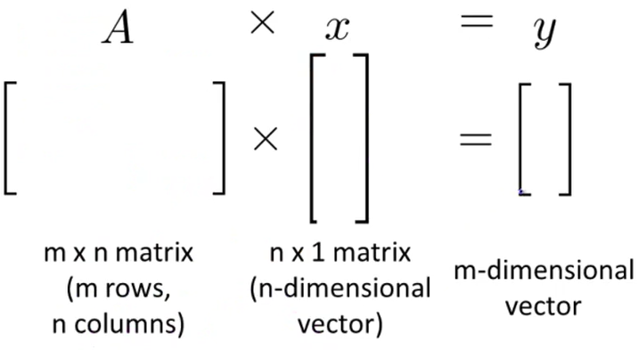

Matrix-Matrix Multiplication

* Let’s start with an example of matrix-matrix multiplication.
$$\left[\begin{matrix}1 & 3 & 2 \\ 4 & 0 & 1\end{matrix}\right]×\left[\begin{matrix}1 & 3 \\ 0 & 1 \\ 5 & 2\end{matrix}\right]=\left[\begin{matrix}1×1+3×0+2×5 & 1×3+3×1+2×2 \\ 4×1+0×0+1×5 & 4×3+0×1+1×2\end{matrix}\right]=\left[\begin{matrix}11 & 10 \\ 9 & 14\end{matrix}\right]$$

* Here is the rule about multiplying matrices together.

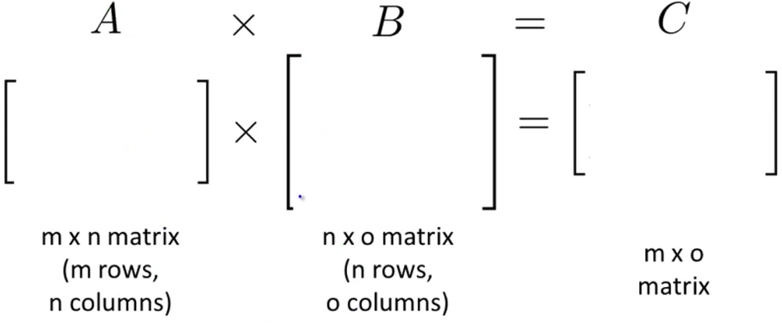

* The $i^{th}$ column of matrix $C$ is obtained by multiplying $A$ with the $i^{th}$ column of matrix $B$ (for $i=0, 1, 2, …, o$).

Matrix Multiplication Properties

* Let $A$ and $B$ be matrices. Then, in general, $A×B≠B×A$ (**not commutative**).
* Let $A$, $B$ and $C$ be matrices. Then, in general, $A×\left(B×C\right)=(A×B)×C$ (**associative**).
* The **identity matrix** is the matrix that, if multiplied with any other (valid) matrix, will output the original matrix.
* It is denoted by $I$ or $I_{n×n}$. Examples of these matrices include the following.
$$\left[1\right] \left(1×1\right)$$

$$\left[\begin{matrix}1 & 0 \\ 0 & 1\end{matrix}\right] \left(2×2\right)$$

$$\left[\begin{matrix}1 & 0 & 0 \\ 0 & 1 & 0 \\ 0 & 0 & 1\end{matrix}\right] (3×3)$$

* For any matrix $A$, $A×I=I×A=A$. **For $A×I$** , if $A$ is an $m×n$ matrix, then $I$ must be the $n×n$ identity matrix. **For $I×A$** , if $A$ is an $m×n$ matrix, then $I$ must be the $m×m$ identity matrix.
* Thus, this really says $A_{m×n}×I_{n×n}=I_{m×m}×A_{m×n}=A_{m×n}$.

Inverse and Transpose:

* Now we will look at the inverse element – the element such that when multiplied by the original, yields the identity element.
* In the space of $R$, not all numbers have an inverse ($0^{-1} d.n.e$). What is the inverse of a matrix?
* **Matrix Inverse:** If $A$ is an $m×m$ matrix (square matrix), and if it has an inverse, then $AA^{-1}=A^{-1}A=I$.
* Let’s look at an example of this.
$$\left[\begin{matrix}3 & 4 \\ 2 & 16\end{matrix}\right]\left[\begin{matrix}0.4 & -0.1 \\ -0.05 & 0.075\end{matrix}\right]=\left[\begin{matrix}1 & 0 \\ 0 & 1\end{matrix}\right]=I_{2×2}$$

* The actual way to find the inverse of a matrix is shown below.
$$A=\left[\begin{matrix}a & b \\ c & d\end{matrix}\right]$$

$$A^{-1}=\frac{1}{ad-bc}\left[\begin{matrix}d & -b \\ -c & a\end{matrix}\right]$$

* This is only the case for a $2×2$ matrix. Also, if $ad-bc=0$, then the inverse of matrix $A$ does not exist. Matrices that don’t have an inverse are called “singular” or “degenerate”.
* **Matrix Transpose:** Let $A$ be an $m×n$ matrix and let $B=A^{T}$. Then $B$ is an $n×m$ matrix and,
$$B_{ij}=A_{ji} (for all i,j)$$

* Let’s see the example below.

$$A=\left[\begin{matrix}1 & 2 & 0 \\ 3 & 5 & 9\end{matrix}\right]$$

$$A^{T}=\left[\begin{matrix}1 & 3 \\ 2 & 5 \\ 0 & 9\end{matrix}\right]$$

**Week 2**

**Multivariate Linear Regression**

Multiple Features

* In our previous gradient descent models, we just had one feature upon which we predicted the output. E.g. We used house size (ft2) to predict house price ($1000s).
* Now imagine we had multiple attributes to use to predict the price of the house as shown below.

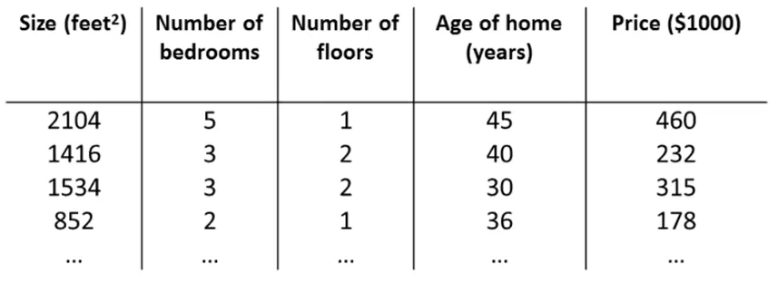

* We use $x_{1},x_{2},x_{3},…,x_{n}$ to denote each of the $n$ features and $y$ to denote the output variable. In the case above $n=4$.
* Here is some additional required notation:
  + $n$ = number of features
  + $x^{\left(i\right)}$ = input (features) of $i^{th}$ training example
  + $x_{j}^{\left(i\right)}$ = value of feature $j$ in $i^{th}$ training example
* In the example table above, we can use the notation to represent specific rows, columns, or cells.
$$x^{\left(2\right)}=\left[\begin{aligned}1416 \\ 3 \\ 2 \\ 40\end{aligned}\right]∈R^{n} (in this case n=4)$$

$$x_{3}^{\left(2\right)}=2$$

* Now that we have multiple features, our hypothesis becomes the following.
$$h_{θ}\left(x\right)=θ_{0}+θ_{1}x_{1}+θ_{2}x_{2}+…+θ_{n}x_{n}$$

* For convenience of notation $x_{0}=1$ and thus $x_{0}^{\left(i\right)}=1$. Then, this vector $x$ that contains all the features $x_{0}, x_{1},x_{2},…,x_{n}$ becomes the following.
$$x=\left[\begin{aligned}x_{0} \\ x_{1} \\ x_{2} \\ ⋮ \\ x_{n}\end{aligned}\right]∈R^{n+1}$$

* We can also think of our parameters $θ$ as a vector.
$$θ=\left[\begin{aligned}θ_{0} \\ θ_{1} \\ θ_{2} \\ ⋮ \\ θ_{n}\end{aligned}\right]∈R^{n+1}$$

* Now we can rewrite our hypothesis as the following.

$$h_{θ}\left(x\right)=θ_{0}x_{0}+θ_{1}x_{1}+θ_{2}x_{2}+…+θ_{n}x_{n}, where x_{0}=1$$

$$h_{θ}\left(x\right)=[\begin{matrix}θ_{0} & θ_{1} & θ_{2} & … & θ_{n}\end{matrix}]\left[\begin{aligned}x_{0} \\ x_{1} \\ x_{2} \\ ⋮ \\ x_{n}\end{aligned}\right]$$

$$∴h_{θ}\left(x\right)=θ^{T}x$$

Gradient Descent for Multiple Variables

* Since now we are working with multivariate linear regression, our cost function becomes the following.
$$J\left(θ\right)=\frac{1}{2m}\sum_{i=1}^{m}{{\left(h_{θ}\left(x^{\left(i\right)}\right)-y^{\left(i\right)}\right)}^{2}}$$

$$J\left(θ\right)=\frac{1}{2m}\sum_{i=1}^{m}{{\left(θ^{T}x^{\left(i\right)}-y^{\left(i\right)}\right)}^{2}}$$

$$J\left(θ\right)=\frac{1}{2m}\sum_{i=1}^{m}{{\left(\left(\sum_{j=0}^{n}{θ_{j}x_{j}^{\left(i\right)}}\right)-y^{\left(i\right)}\right)}^{2}}$$

* In the equation above, $θ$ is a $n+1$ dimensional vector.
* Here is the new gradient descent algorithm for $n$ features.
$$repeat until convergence \{ \\ θ_{j}≔θ_{j}-α\frac{∂}{∂θ_{j}}J\left(θ\right) update for j=0, 1,…,n \\ \}$$

* We can expand the partial derivative term to get a new update rule for $n≥1$ features.

$$repeat until convergence \{ \\ θ_{j}≔θ_{j}-α\frac{1}{m}\sum_{i=1}^{m}{x_{j}^{\left(i\right)}∙\left(h_{θ}\left(x^{\left(i\right)}\right)-y^{\left(i\right)}\right)} update θ_{j} for j=0, 1,…,n \\ \}$$

Gradient Descent in Practice I – Feature Scaling

* Here is a practical idea to make **feature scaling** work.
  + **Idea:** make sure features are on a similar scale
  + E.g. $x_{1}$ = size (0–2000 ft2) and = number of bedrooms (1–5)
* When you have such different scales, when you plot the contour graph of $θ_{1}$ and $θ_{2}$ (ignoring $θ_{0}$), you get a very narrow elliptical contour as shown below.

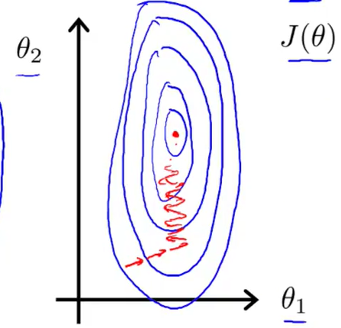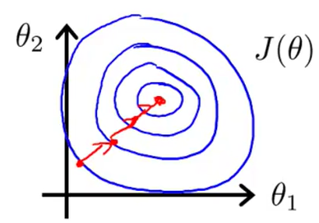

* Thus, the red arrows show that the gradient descent algorithm takes a long time to reach the global minimum.
* In turn, if you scale the features, then it is much easier for the gradient descent algorithm to move towards the global minimum in a smaller number of steps.
* Thus, you can apply a scaling technique to make all the features on a similar scale.
$$x_{1}=\frac{size \left(ft^{2}\right)}{2000}→0≤x_{1}≤1 \\ x_{2}=\frac{number of bedrooms}{5}→0≤x_{2}≤1$$

* In general, you want to get every feature into an approximate range of $-1≤x_{i}≤1$.
* In addition to feature scaling, it can be useful to apply **mean normalization**.
  + Replace $x_{i}$ with $x_{i}-μ_{i}$ to make features have approximately zero mean. (Do not apply to $x_{0}=1$.)
  + E.g. Let’s do this with the same example.
$$x_{1}=\frac{size \left(ft^{2}\right)-1000}{2000}→-0.5≤x_{1}≤0.5 \\ x_{2}=\frac{number of bedrooms-2}{5}→-0.5≤x_{2}≤0.5$$

* In general, to make a feature $x_{i}$ scaled appropriately, we apply the following transformation to each element.
$$x_{i}≔\frac{x_{i}-μ_{i}}{s_{i}}$$

* In the equation, $x_{1}$ is the feature vector itself, $μ_{i}$ is the average value of $x_{i}$ in the training set, and $s_{i}$ is the standard deviation of $x_{i}$ in the training set or the range ($\max{x_{i}}-\min{x_{i}}$).

Gradient Descent in Practice II – Learning Rate

* Now, we will show how to choose an effective learning rate $α$.
* Firstly, to make sure gradient descent is working properly, we can graph the number of iterations versus the $\min_{θ}{J\left(θ\right)}$.
* Overall, the graph should decrease over the number of iterations. An example of an automatic convergence test:
  + Declare convergence if $J\left(θ\right)$ decreases by less than ${10}^{-3}$ in one iteration.
* If your graph is increasing, then you need to use a smaller $α$.
  + For sufficiently small $α$, $J\left(θ\right)$ should decrease on every iteration.
  + But if $α$ is too small, gradient descent may take very long to converge.

Features and Polynomial Regression

* Now we’ll look at how to select appropriate features for a model to develop a powerful algorithm to estimate the output.
* Let’s look at housing prices. Suppose you pick two features to model your hypothesis function.
$$h_{θ}\left(x\right)=θ_{0}+θ_{1}×frontage+θ_{2}×depth$$

* You might feel that it’s better to model house price based on the total area rather than these frontage and depth dimensions. Thus, you can make a new variable for area.
$$Area:x=frontage×depth$$

$$h_{θ}\left(x\right)=θ_{0}+θ_{1}x$$

* You can also pick non-linear models if you think the curve doesn’t follow a straight line, as shown below.

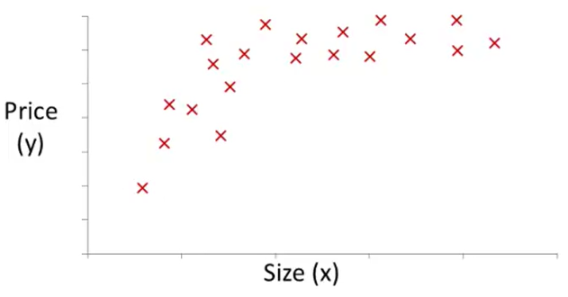

* You might feel that it follows a quadratic model better $h_{θ}\left(x\right)=θ_{0}+θ_{1}x+θ_{2}x^{2}$. However, a quadratic function does fall back down. So now we want to fit a cubic model $h_{θ}\left(x\right)=θ_{0}+θ_{1}x+θ_{2}x^{2}+θ_{3}x^{3}$.
* It turns out this requires a small modification to our original algorithm.
$$h_{θ}\left(x\right)=θ_{0}+θ_{1}x+θ_{2}x^{2}+θ_{3}x^{3} \\ h_{θ}\left(x\right)=θ_{0}+θ_{1}\left(size\right)+θ_{2}{\left(size\right)}^{2}+θ_{3}{\left(size\right)}^{3}$$

* Then we set the variables to the following.
$$x_{1}=\left(size\right) \\ x_{2}={\left(size\right)}^{2} \\ x_{3}={\left(size\right)}^{3}$$

* Then, we get the hypothesis function.
$$h_{θ}\left(x\right)=θ_{0}+θ_{1}x_{1}+θ_{2}x_{2}+θ_{3}x_{3}$$

* If you do choose your features like this, then feature scaling is **very important**, since $\operatorname{range}\left(x_{3}\right)≫\operatorname{range}\left(x_{2}\right)≫\operatorname{range}\left(x_{1}\right)$.
* You could also choose non-polynomial models to fit the data.
$$h_{θ}\left(x\right)=θ_{0}+θ_{1}x+θ_{2}\sqrt{x} \\ h_{θ}\left(x\right)=θ_{0}+θ_{1}\left(size\right)+θ_{2}\sqrt{\left(size\right)}$$

* Then we just do the same thing as before.

$$x_{1}=\left(size\right) \\ x_{2}=\sqrt{\left(size\right)}$$

**Computing Parameters $θ$ Analytically**

Normal Equation

* The method of the **normal equation** gives a way to solve for the parameters $θ$ analytically.
* Let’s take a simplified cost function $J\left(θ\right)$ that only consists of one parameter. Thus $θ∈R$, so it’s a one-dimensional vector or a scalar.

$$J\left(θ\right)=aθ^{2}+bθ+c$$

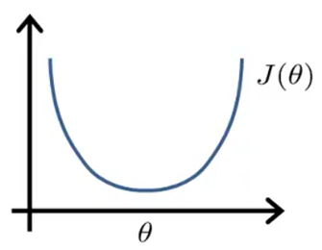

* To find the global minimum of this function, we must find where the derivative $\frac{d}{dθ}J\left(θ\right)=0$ and solve for $θ$.
* However, when we work with many features, then $θ∈R^{n+1}$. The cost function also becomes the following.
$$J\left(θ_{0},θ_{1},…,θ_{n}\right)=\frac{1}{2m}\sum_{i=1}^{m}{{\left(h_{θ}\left(x^{\left(i\right)}\right)-y^{\left(i\right)}\right)}^{2}}$$

* Then, for every $j$ from $1$ to $n$, you find where the partial derivative of the parameter $θ_{j}$ is equal to $0$.
$$\frac{∂}{∂θ_{j}}J\left(θ\right)=…=0$$

* Let’s try to walk through an example using the normal equation method.

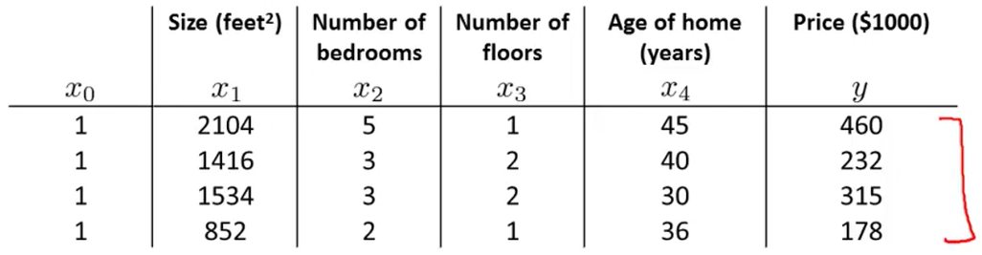

* Let’s pretend there are only $m=4$ training examples to work with. We have $4$ different features that we are looking at and an extra feature $x_{0}=1$ that just makes the math easier.
* Now let’s compile all the features into a single matrix $X$. The output values will be stored in a vector $y$.
$$X=\left[\begin{matrix}1 & 2104 & 5 & 1 & 45 \\ 1 & 1416 & 3 & 2 & 40 \\ 1 & 1534 & 3 & 2 & 30 \\ 1 & 852 & 2 & 1 & 36\end{matrix}\right] \\ y=\left[\begin{matrix}460 \\ 232 \\ 315 \\ 178\end{matrix}\right]$$

* So $X$ is a $m×\left(n+1\right)$ matrix and $y$ is a $m×1$ vector (or a $m$-dimensional vector). To analytically solve for the best parameters $θ$, you use the following formula.
$$θ={\left(X^{T}X\right)}^{-1}X^{T}y$$

* Let’s look at a very general case. Let’s say we have $m$ training examples $\left(x^{\left(1\right)},y^{\left(1\right)}\right),\left(x^{\left(2\right)},y^{\left(2\right)}\right),…,\left(x^{\left(m\right)},y^{\left(m\right)}\right)$; and you have $n$ features. Each $x^{(i)}$ is a vector like the following.
$$x^{\left(i\right)}=\left[\begin{matrix}x_{0}^{\left(i\right)} \\ x_{1}^{\left(i\right)} \\ x_{2}^{\left(i\right)} \\ ⋮ \\ x_{n}^{\left(i\right)}\end{matrix}\right]∈R^{n+1}$$

* Then we have a matrix $X$ called the **design matrix**. We transpose each of the feature vectors $x^{(i)}$ and put it as a row vector into the matrix $X$.
$$X=\left[\begin{matrix}…{\left(x^{\left(1\right)}\right)}^{T}… \\ …{\left(x^{\left(2\right)}\right)}^{T}… \\ ⋮ \\ …{\left(x^{\left(m\right)}\right)}^{T}…\end{matrix}\right]$$

* For example, if I have an $x^{\left(i\right)}$ that only has one feature, we get the following vector.
$$x^{\left(i\right)}=\left[\begin{matrix}1 \\ x_{1}^{\left(i\right)}\end{matrix}\right]$$

* Then the design matrix $X$ is the following.
$$X=\left[\begin{matrix}1 & x_{1}^{\left(1\right)} \\ 1 & x_{1}^{\left(2\right)} \\ ⋮ & ⋮ \\ 1 & x_{1}^{\left(m\right)}\end{matrix}\right]$$

* The vector $y$ is still the same.
$$y=\left[\begin{matrix}y^{\left(1\right)} \\ y^{\left(2\right)} \\ ⋮ \\ y^{\left(m\right)}\end{matrix}\right]$$

* Then we can calculate $θ$ using $θ={\left(X^{T}X\right)}^{-1}X^{T}y$.
  + This yields the optimal value of $θ$. When should each method be used?
  + Gradient Descent
    - Need to chose $α$
    - Needs many iterations
 $O\left(kn^{2}\right)$

   - Works well even when $n$ is large
  + Normal Equation
    - No need to chose $α$
    - Don’t need to iterate
 $O\left(n^{3}\right)$

   - Need to compute ${\left(X^{T}X\right)}^{-1}$
    - Slow if $n$ is very large

Normal Equation Non-Invertibility

* The normal equation is given by $θ={\left(X^{T}X\right)}^{-1}X^{T}y$.
  + But what if $X^{T}X$ is non-invertible (singular/degenerate)?
* $X^{T}X$ can rarely be non-invertible. But it is non-invertible when you have one of two problems.
  + Redundant features (linearly dependent)
    - E.g. $x_{1}$ = size in ft2 and = size in m2
  + Too many features ($m≤n$)
    - Delete some features, or use regularization

**Octave/Matlab Tutorial**

Vectorization

* Let’s say we have the following hypothesis function.
$$h_{θ}\left(x\right)=\sum_{j=0}^{n}{θ_{j}x_{j}} \\ h_{θ}\left(x\right)=θ^{T}x$$

* The above equations show that there is two ways to calculate the prediction output $h_{θ}\left(x\right)$.
  + Un-vectorized implementation
    - **prediction = 0.0;**
    - **for j=1:n+1**
    - **prediction = prediction + theta(j) * x(j);**
    - **end**
  + Vectorized implementation
    - **prediction = theta’ * x**
* Let’s look at a more sophisticated and involved example. Say we want to calculate the gradient descent until convergence for all $θ$.
$$repeat until convergence \{ \\ θ_{j}≔θ_{j}-α\frac{1}{m}\sum_{i=1}^{m}{x_{j}^{\left(i\right)}∙\left(h_{θ}\left(x^{\left(i\right)}\right)-y^{\left(i\right)}\right)} update θ_{j} for j=0, 1,…,n \\ \}$$

* We could do this using a for loop, but that would be extremely tedious and inefficient. Below is a vectorized solution.
  + Vectorized implementation
    - **theta = theta – alpha * delta**
    - where **delta** = $\frac{1}{m}\sum_{i=1}^{m}{x_{j}^{\left(i\right)}∙\left(h_{θ}\left(x^{\left(i\right)}\right)-y^{\left(i\right)}\right)}$

**Week 3**

**Classification and Representation**

Classification

* In classification problems, the output variable $y$ is a discrete-valued output. The most popular tool to solve this problem is called **logistic regression**.
* Here are some examples of classification problems.
  + Email: spam / not spam?
  + Online Transactions: fraudulent (yes / no)?
  + Tumour: malignant / benign?
* In all cases, the output variable $y$ can take on two values since it is a **binary classification problem**.
$$y∈\left\{0, 1\right\}$$

* $0$ represents the “negative class” (e.g. benign tumour), while $1$ represents the “positive class” (e.g. malignant tumour).
* Later, we’ll talk about multiclass problems, where $y∈\left\{0, 1, 2,…,n\right\}$, where $n$ is the number of classes.
* Applying a linear regression to a classification problem isn’t a good idea – often times, the straight line gets skewed by some of the data points and you don’t have a good idea of how to classify the points anymore.
* A logistic regression, in turn, has the property that $0≤h_{θ}\left(x\right)≤1$.

Hypothesis Representation

* Our logistic hypothesis must satisfy the property that $0≤h_{θ}\left(x\right)≤1$. We’re going to make a small modification to our linear hypothesis shown below.
$$h_{θ}\left(x\right)=g\left(θ^{T}x\right)$$

* The function $g\left(z\right)$, where $z∈R$, denotes the following function.
$$g\left(z\right)=\frac{1}{1+e^{-z}}$$

* The function above is called the **sigmoid function** or the **logistic function**. When we substitute the function into our hypothesis, we get the following.
$$h_{θ}\left(x\right)=\frac{1}{1+e^{-θ^{T}x}}$$

* Below is a sketch of what this function looks like.

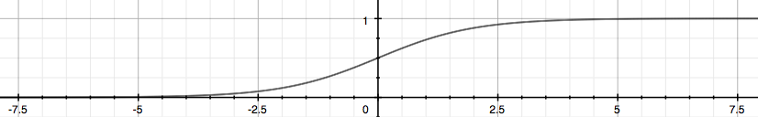

* Thus, this satisfies the property that $0≤h_{θ}\left(x\right)≤1$.
* Here is the interpretation of the output of the hypothesis function $h_{θ}\left(x\right)$.
  + $h_{θ}\left(x\right)$ = estimated probability that $y=1$ on input $x$
 $$h_{θ}\left(x\right)=P\left(y=1 | x;θ\right)$$

 + “Probability that $y=1$, given $x$, parameterized by $θ$.”
* Also, we know that the probability that $y=0$ and $y=1$ will add up to $1$.

$$P\left(y=0 | x;θ\right)+P\left(y=1 | x;θ\right)=1$$

$$P\left(y=0 | x;θ\right)=1-P\left(y=1 | x;θ\right)$$

Decision Boundary

* One way to decide about whether an example falls into $0$ or $1$ is by the following.
  + Predict $y=1$ if $h_{θ}\left(x\right)≥0.5$
  + Predict $y=0$ if $h_{θ}\left(x\right)<0.5$
* From the graph of the function we can tell that the sigmoid function $g\left(z\right)≥0.5$ when $z≥0$. Thus, the hypothesis function $h_{θ}\left(x\right)=g\left(θ^{T}x\right)≥0.5$ when $θ^{T}x≥0$.
* On the other side, by a similar argument $h_{θ}\left(x\right)=g\left(θ^{T}x\right)<0.5$ when $θ^{T}x<0$.
* Now let’s see how this can help us make decisions on an actual training set, given the graph below.

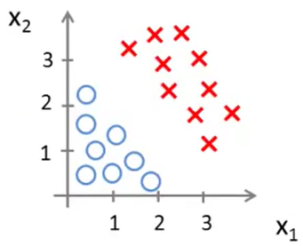

* Let’s say our hypothesis for this data set is the following function.
$$h_{θ}\left(x\right)=g\left(θ_{0}+θ_{1}x_{1}+θ_{2}x_{2}\right)$$

* Now let’s assume that our $θ$ vector is the following. Although we don’t yet know how to calculate our parameters $θ$, we can assume it is given.
$$θ=\left[\begin{aligned}-3 \\ 1 \\ 1\end{aligned}\right]$$

* Thus, we can predict that $y=1$ if $θ^{T}x={\left[\begin{aligned}-3 \\ 1 \\ 1\end{aligned}\right]}^{T}\left[\begin{aligned}x_{0} \\ x_{1} \\ x_{2}\end{aligned}\right]=-3x_{0}+x_{1}+x_{2}=-3+x_{1}+x_{2}≥0$. Values of $x_{1},x_{2}$ that satisfy this inequality yield $h_{θ}\left(x\right)=0.5$ exactly.
* On the graph, this is shown as below. The line cutting between the two halves of the plane is called the **decision boundary**.

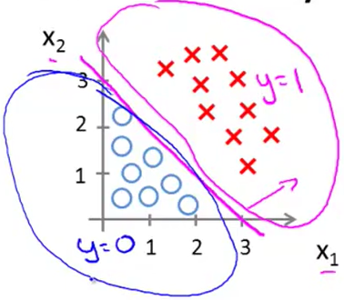

* But what if our boundary is non-linear?

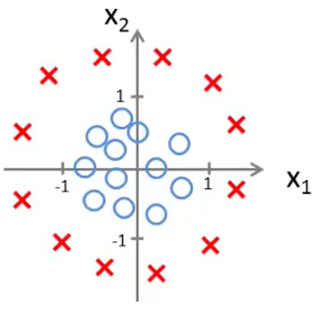

* Then our hypothesis function might look like this.
$$h_{θ}\left(x\right)=g\left(θ_{0}+θ_{1}x_{1}+θ_{2}x_{2}+θ_{3}x_{1}^{2}+θ_{4}x_{2}^{2}\right)$$

* By some procedure, let’s say our parameter choices vector $θ$ ends up like this.
$$θ=\left[\begin{aligned}-1 \\ 0 \\ 0 \\ 1 \\ 1\end{aligned}\right]$$

* Then we predict that $y=1$ if $θ^{T}x=-1+x_{1}^{2}+x_{2}^{2}≥0$.

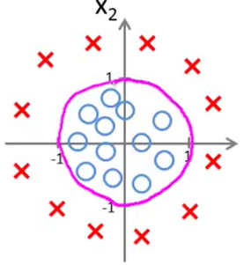

* Anything outside or on the pink line is $y=1$ and anything inside is $y=0$.

**Logistic Regression Model**

Cost Function

* The optimization objective of this model is to choose the ideal set of parameters $θ$ to get the best approximation to the decision boundary.
* Unfortunately, we can’t use the same cost function as we did with linear regression (the sum of the squared error terms).
$$\operatorname{Cost}\left[h_{θ}\left(x^{\left(i\right)}\right),y^{\left(i\right)}\right]={\left(h_{θ}\left(x^{\left(i\right)}\right)-y^{\left(i\right)}\right)}^{2}$$

* When we use the function $h_{θ}\left(x\right)=\frac{1}{1+e^{-θ^{T}x}}$, then the cost function $J\left(θ\right)$ yields a **non-convex** function – it has more than one local optimum. Thus, it cannot guarantee to be globally optimized using the gradient descent method.
* Here is the cost function we’ll use for the logistic regression model.
$$\operatorname{Cost}\left[h_{θ}\left(x\right),y\right]=\left\{\begin{aligned}\begin{matrix}-\log\left(h_{θ}\left(x\right)\right) & if y=1\end{matrix} \\ \begin{matrix}-\log\left(1-h_{θ}\left(x\right)\right) & if y=0\end{matrix}\end{aligned}\right.$$

* The cost function looks something like this **if $y=1$** . If $y=0$, the curve would be flipped around the line $x=0.5$.

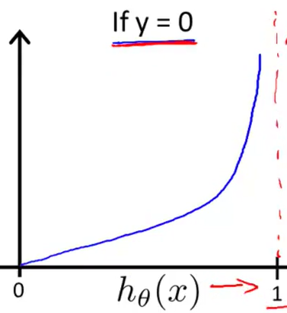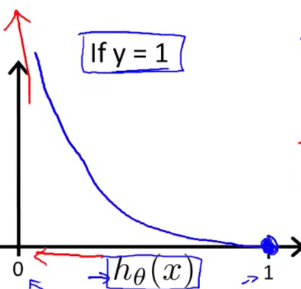

* This captures the intuition that if $h_{θ}\left(x\right)=0$ (predict that $P\left(y=1\right)=0$), but $y$ actually equals $1$, then penalize the algorithm by a very, very large cost. The vice versa happens when $y=0$.

Simplified Cost Function and Gradient Descent

* There’s a simpler way to rewrite the cost function we encountered in the last video.
$$\operatorname{Cost}\left[h_{θ}\left(x\right),y\right]=-y\log\left(h_{θ}\left(x\right)\right)-\left(1-y\right)\log\left(1-h_{θ}\left(x\right)\right)$$

* If $y=1$, then $\operatorname{Cost}\left[h_{θ}\left(x\right),y\right]=-\left(1\right)\log\left(h_{θ}\left(x\right)\right)-\left(1-1\right)\log\left(1-h_{θ}\left(x\right)\right)=-\log\left(h_{θ}\left(x\right)\right)$.
* If $y=0$, then $\operatorname{Cost}\left[h_{θ}\left(x\right),y\right]=-\left(0\right)\log\left(h_{θ}\left(x\right)\right)-\left(1-0\right)\log\left(1-h_{θ}\left(x\right)\right)=-\log\left(1-h_{θ}\left(x\right)\right)$.
* Then, the overall cost function becomes the following.
$$J\left(θ\right)=-\frac{1}{m}\left[\sum_{i=1}^{m}{y^{\left(i\right)}\log\left(h_{θ}\left(x^{\left(i\right)}\right)\right)+\left(1-y^{\left(i\right)}\right)\log\left(1-h_{θ}\left(x^{\left(i\right)}\right)\right)}\right]$$

* Now we must find $\min_{θ}{J\left(θ\right)}$.
* To do this, we will use gradient descent.
$$repeat until convergence \{ \\ θ_{j}≔θ_{j}-α\sum_{i=1}^{m}{x_{j}^{\left(i\right)}∙\left(h_{θ}\left(x^{\left(i\right)}\right)-y^{\left(i\right)}\right)} update for j=0, 1,…,n \\ \}$$

* A vectorized implementation for this is the following.

$$repeat until convergence \{ \\ θ≔θ-\frac{α}{m}X^{T}\left(g\left(Xθ\right)-y\right) \\ \}$$

Advanced Optimization

* Other than gradient descent, there are a variety of optimization algorithms that solve the same problem.
  + Gradient Descent
  + Conjugate Gradient
  + BFGS (Broyden-Fletcher-Goldfarb-Shanno Algorithm)
  + L-BFGS (Limited Memory-BFGS Algorithm)
* Here are the advantages and disadvantages of these algorithms.
  + Advantages
    - No need to pick $α$
    - Often faster than gradient descent
  + Disadvantages
    - More complex
* Let’s see how to implement one in Octave/Matlab.
  + E.g. $J\left(θ\right)={\left(θ_{1}-5\right)}^{2}+{\left(θ_{2}-5\right)}^{2}$.
$\frac{∂}{∂θ_{1}}J\left(θ\right)=2\left(θ_{1}-5\right)$

$\frac{∂}{∂θ_{2}}J\left(θ\right)=2\left(θ_{2}-5\right)$

* To implement this, you would create the following function.
  + **function [jVal, gradient] = costFunction(theta)**
  + **jVal = (theta(1) – 5)^2 + (theta(2) – 5)^2;**
  + **gradient = zeros(2, 1);**
  + **gradient(1) = 2*(theta(1) – 5);**
  + **gradient(2) = 2*(theta(2) – 5);**
  + **end**
* Then, you would minimize this function by using a Matlab library.
  + **options = optimset(‘GradObj’, ‘on’, ‘MaxIter’, ‘100’);**
  + **initialTheta = zeros(2, 1);**
  + **[optTheta, functionVal, exitFlag] = fminunc(@costFunction, initialTheta, options);**
* If we want to apply this to logistic regression more generally, we create the following function.

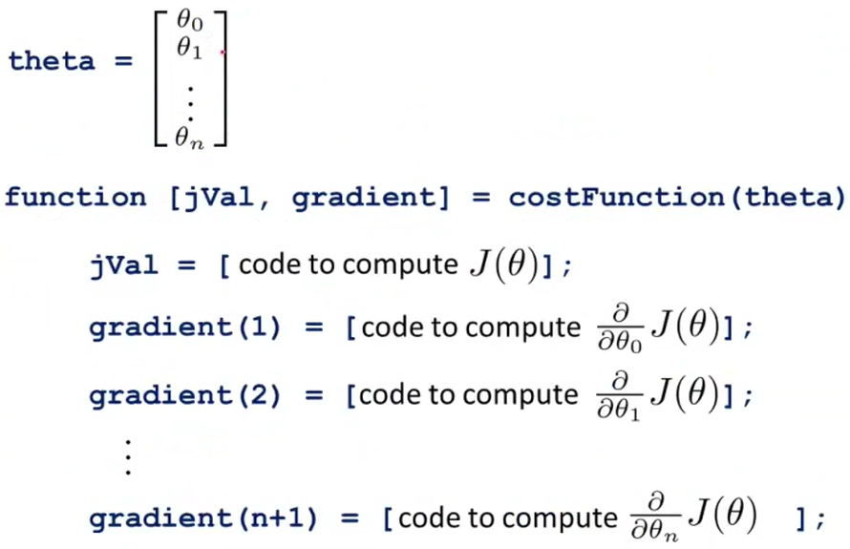

Multiclass Classification: One-vs-All

* Here are some examples of multiclass classification problems.
  + Email foldering / tagging: Work, Friends, Family, Hobby
  + Medical diagrams: Not ill, Cold, Flu
    - Not ill ($y=1$), Cold ($y=2$), Flu ($y=3$)
  + Weather: Sunny, Cloudy, Rainy, Snowy

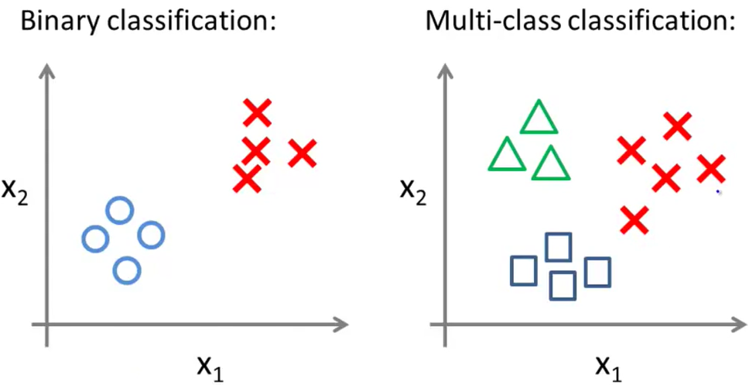

* To create decision boundaries around all 3 classes, we essentially separate out the data set. So the first data set may look like this.

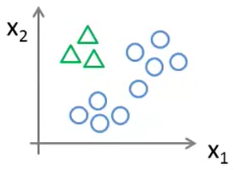

* The triangles are treated as 1 class and everything else is treated as another class. As a formula, we have different hypothesis functions based on which class we are looking at.

$$h_{θ}\left(x\right)=P\left(y=i | x;θ\right), for i=1, 2, 3,…$$

**Regularization**

The Problem of Overfitting

* When deciding what model to use to fit a curve, there are a couple of problems, specifically **underfitting** and **overfitting**.

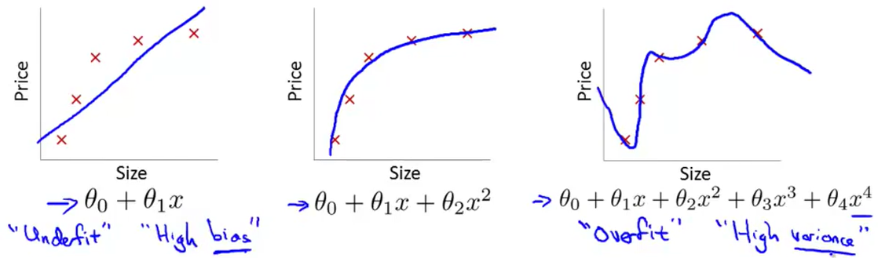

* **Overfitting:** If we have too many features, the learned hypothesis may fit the training set very well ($J\left(θ\right)≈0$), but may fail to generalize to new examples.
* If a training set is being overfitted, there are a couple things to remedy the problem.

1. Reduce number of features.

* Manually select features to keep.
* Model selection algorithm (later).

1. Regularization

* Keep all features, but reduce parameters/values of $θ_{j}$.
* Works well with lots of features, each which contributes a little bit to predicting $y$.

Cost Function

* Suppose we have two different models to predict housing prices.

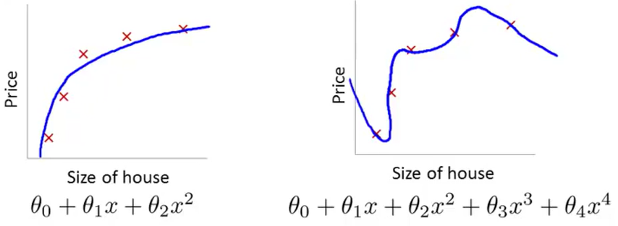

* Then, we want to make $θ_{3}$ and $θ_{4}$ smaller because they are contributing to the awkward behaviour of the function.
* Then, we can modify the cost function to the following.
$$\min_{θ}{\frac{1}{2m}\sum_{i=1}^{m}{{\left(h_{θ}\left(x^{\left(i\right)}\right)-y^{\left(i\right)}\right)}^{2}}+100θ_{3}^{2}+100θ_{4}^{2}}$$

* Thus, when we minimize the function, we get $θ_{3}≈0$ and $θ_{4}≈0$. And we essentially end up with a quadratic function with small contributions from $θ_{3},θ_{4}$ that make it more accurate.
* If we want to shrink all our parameters, then we can add an extra term at the end of the cost function.

$$J\left(θ\right)=\frac{1}{2m}\sum_{i=1}^{m}{{\left(h_{θ}\left(x^{\left(i\right)}\right)-y^{\left(i\right)}\right)}^{2}}+λ\sum_{j=1}^{n}{θ_{j}^{2}}$$

Regularized Linear Regression

* When you apply the update rule on linear regression with a regularized term at the end, you get the following.
$$repeat until convergence \{ \\ θ_{j}≔θ_{j}\left(1-α\frac{λ}{m}\right)-α\frac{1}{m}\sum_{i=1}^{m}{x_{j}^{\left(i\right)}∙\left(h_{θ}\left(x^{\left(i\right)}\right)-y^{\left(i\right)}\right)} update for j=1, 2,…,n \\ \}$$

* Usually, the term $1-α\frac{λ}{m}$ is slightly less than $1$, when $α$ is small and $m$ is quite large. Thus, the change is not big enough to completely change the function, but remove some of its irregularities.
* Now, we also used the normal equation method to solve for the parameters. How would that be fixed?
* Well the normal equation with the regularized term would be the following.
$$θ={\left(X^{T}X+λ\left[\begin{matrix}0 & & & & \\ & 1 & & & \\ & & 1 & & \\ & & & ⋱ & \\ & & & & 1\end{matrix}\right]\right)}^{-1}X^{T}y$$

* The large matrix in the equation is an identity matrix of size $(n+1)×\left(n+1\right)$, except that the top-left element of the matrix is $0$.

Regularized Logistic Regression

* Here is the regularized logistic cost function.
$$J\left(θ\right)=-\frac{1}{m}\left[\sum_{i=1}^{m}{y^{\left(i\right)}\log\left(h_{θ}\left(x^{\left(i\right)}\right)\right)+\left(1-y^{\left(i\right)}\right)\log\left(1-h_{θ}\left(x^{\left(i\right)}\right)\right)}\right]+\frac{λ}{2m}\sum_{j=1}^{n}{θ_{j}^{2}}$$

* Then, the new gradient descent algorithm becomes the following.

$$repeat until convergence \{ \\ θ_{j}≔θ_{j}\left(1-α\frac{λ}{m}\right)-α\frac{1}{m}X^{T}\left(g\left(Xθ\right)-y\right) update for j=1, 2,…,n \\ \}$$